Contents

1. Visual Studio and GitHub Extension 2

2. GitHub clone 2

3. Clone to local Git repository 2

4. Check out code in Solution Explore 3

5. Add references 4

6. Specify startup project 7

7. Run project 8

This document provides guidance to clone the XXE project from GitHub to local repository and run the project in Visual Studio.

# Visual Studio and GitHub Extension

In order to download the XXE from GitHub and open it in Visual Studio, you should complete the following steps: a. install Visual Studio; b. install GitHub Extension for Visual Studio; c. log in your GitHub account in the Visual Studio.

# GitHub clone

In the GitHub page for XXE project, click “Clone or download”, and then choose to “Open in Visual Studio”.

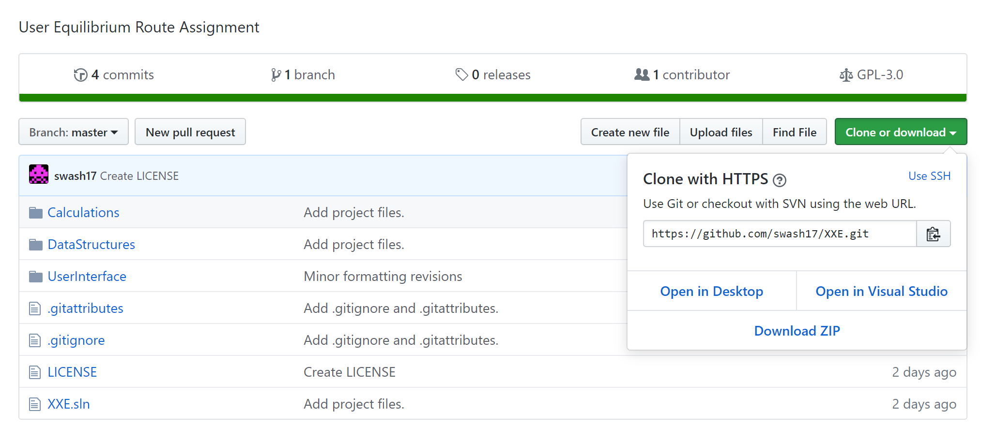

# Clone to local Git repository

After launching Visual Studio, it will ask you to select a local folder to clone the XXE project to local Git repository. After cloning, double click that repository and the software solution will show up.

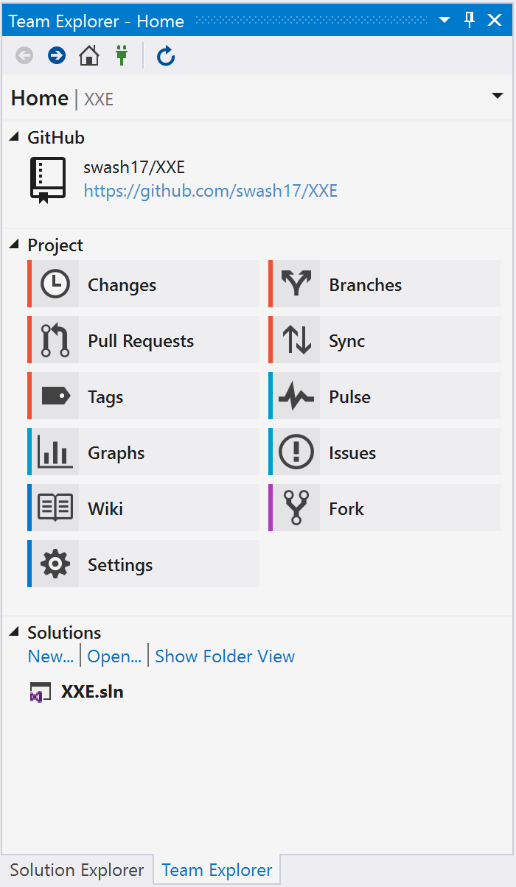

# Check out code in Solution Explore

The code of the software can be found in Solution Explore. There are three projects inside the solution: “Calculations”, “DataStructures”, and “UserInterface”.

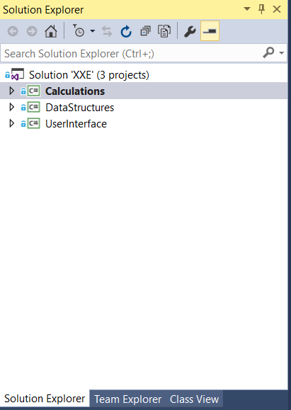

# Add references

For each project, click References, there are some references that need to be specified, these references include DLLs from HCM-CALC software, as shown in the figures below.

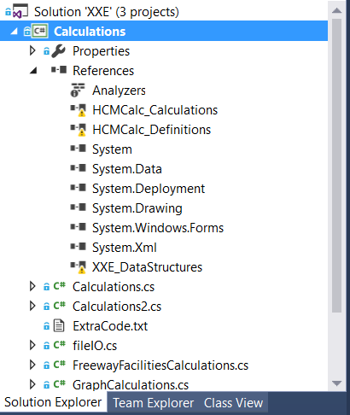

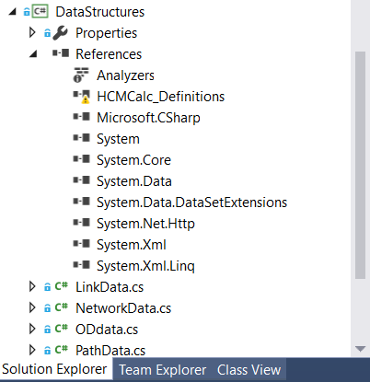

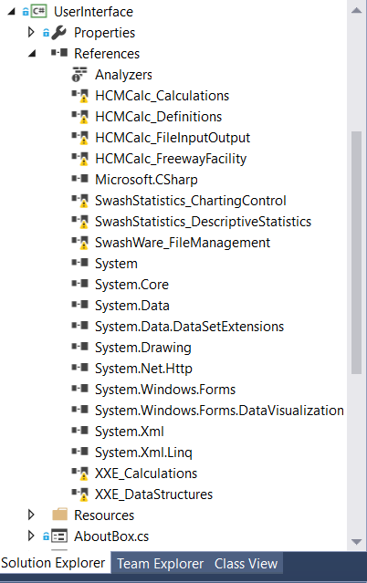

For HCM-CALC references, users need to contact Prof. Scott Washburn ([swash@ce.ufl.edu](mailto:swash@ce.ufl.edu)) for installation file of the HCM-CALC. Once the HCM-CALC is installed, for each project, right click “References” and add the missing references by referencing the relative DLLs from the HCM-CALC installation folder.

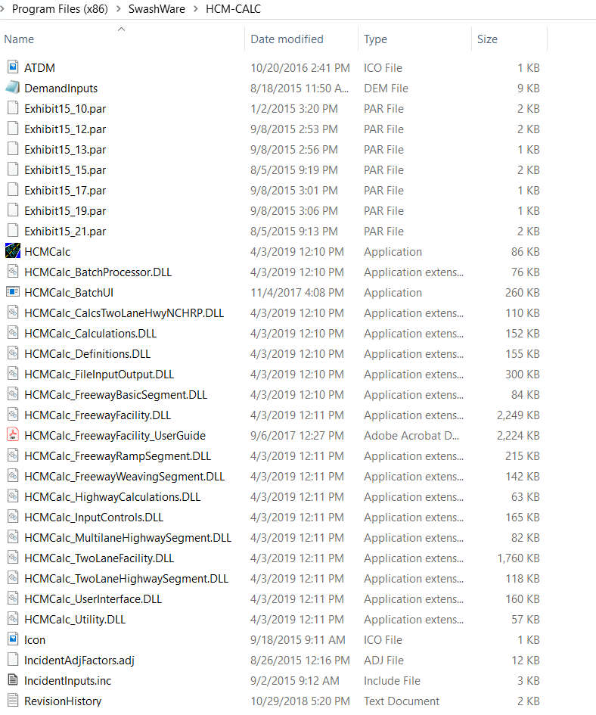

Once all the relative HCM-CALC DLLs are referenced, right click “Solution ‘XXE’ (3 projects)” and choose “Build Solution”.

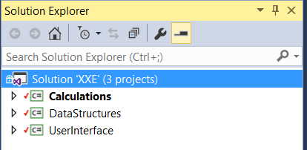

# Specify startup project

Right click “UserInterface” project in Solution Explore and select “Set as StartUp Project”.

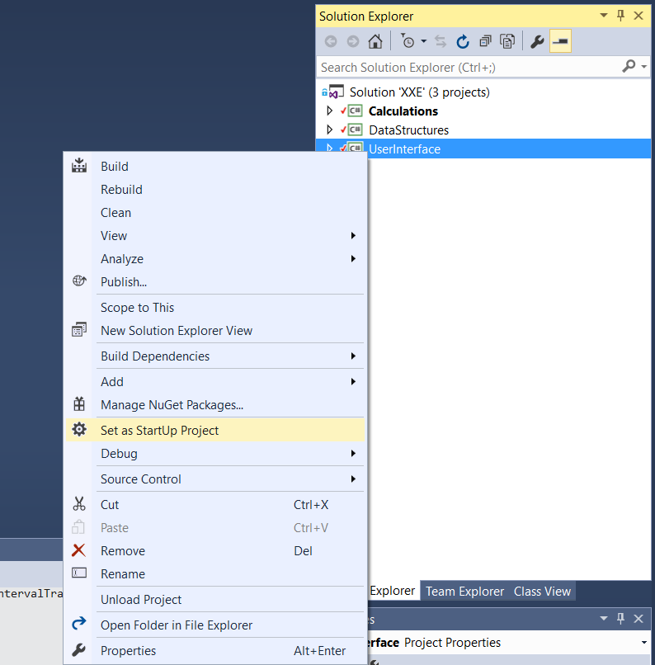

# Run project

Build the project solution and click “Start” to run the project.

